From: Don

To: The Record

Subject: Hostek Configuration for BBSG (see emails from hostek on 5/3/2015 for “official” details

Date: 5/9/2015

Quick MySQL note. To copy the lt schema/database to ltdv1, USE NAVICAT. Right click on lt, select data transfer, then select local MySQL, and ltdv1. Ltdev1 must already exist.

MySQL data is in C:\Program**Data**\MySQL\MySQL Server 5.6\data\...

See “Server Instance DataBase DSN.xlsx” for details on DSN’s in all formats and locations

Link to control panel: <https://wcp.hostek.com/Login.aspx>

Link to lucee. Note the locations of files for web contexts.

<http://216.15.141.160:8888/lucee/admin/server.cfm>

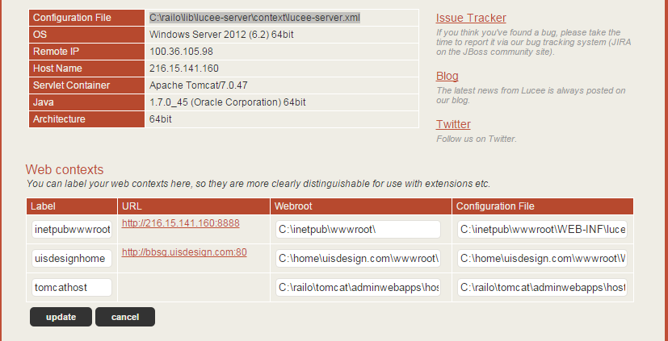

After logging into Hostek Control Panel. In domain: uisdesign, Click on MySQL within Databases.

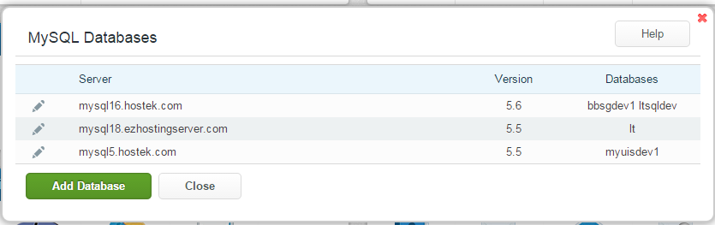

Here is “pre VPS” MySQL

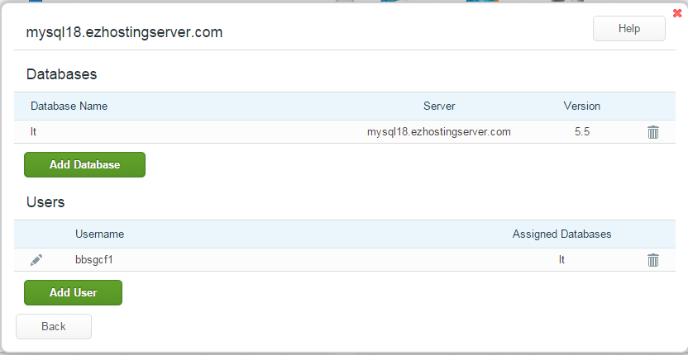

Lthostek is the development database Datasource in CF on hostek

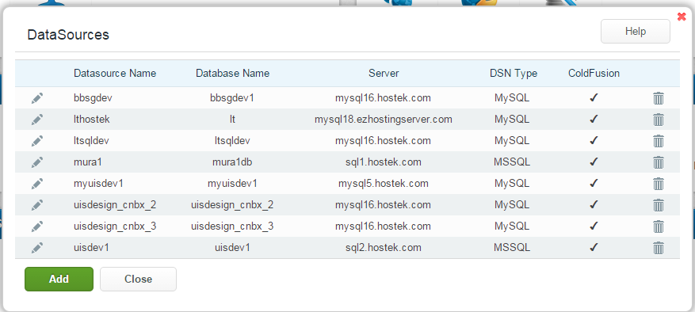

Here is link to development application, in a subdomain: <http://bbsgdv1.uisdesign.com/?fwreinit=1>

Here are subdomains

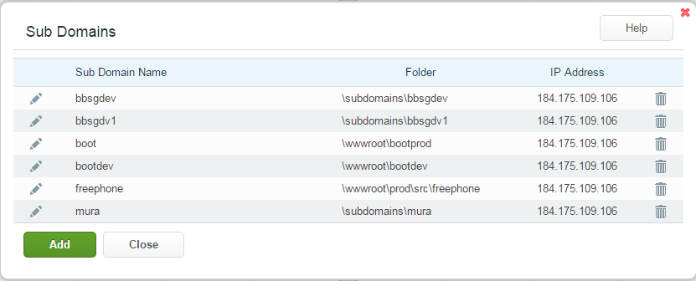

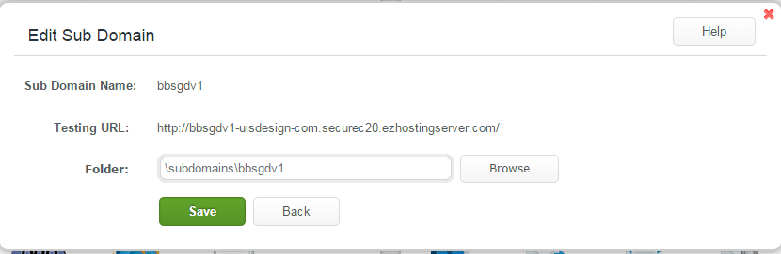

Here is file manager

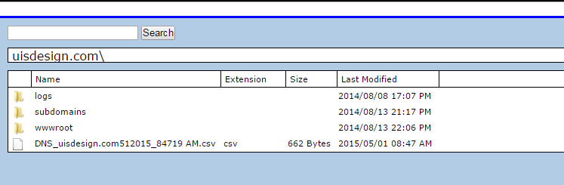

Here are corresponding entries in filezilla, under site manager

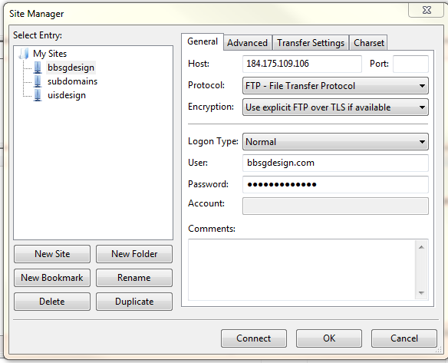

Here is location of development source code, under bbsgdesign connection. Copy stuff from LOCAL C:\ColdFusion11\cfusion\wwwroot to that remote location, except .git, CFIDE and WEB-INF.

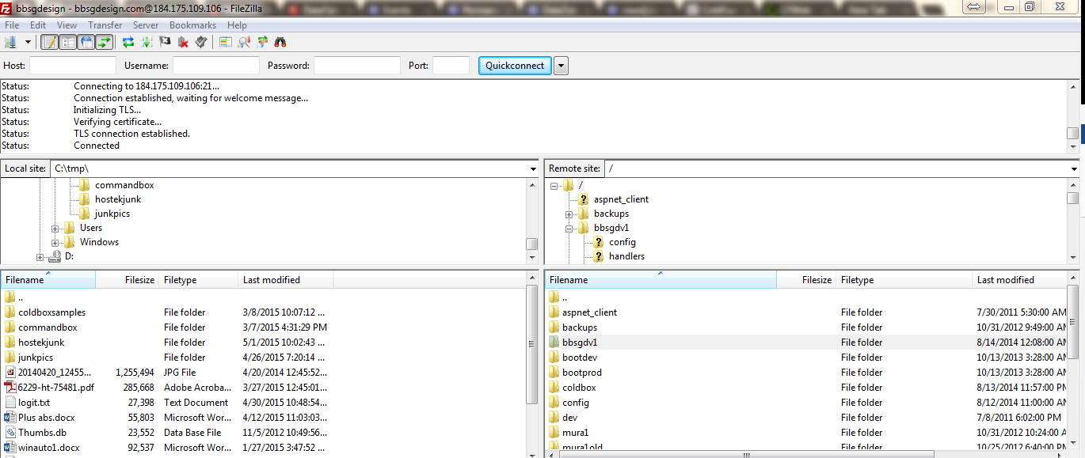

In local copy of MySQL,

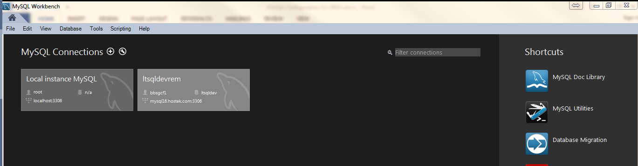

Here is a connection in MySQL Data Migration.

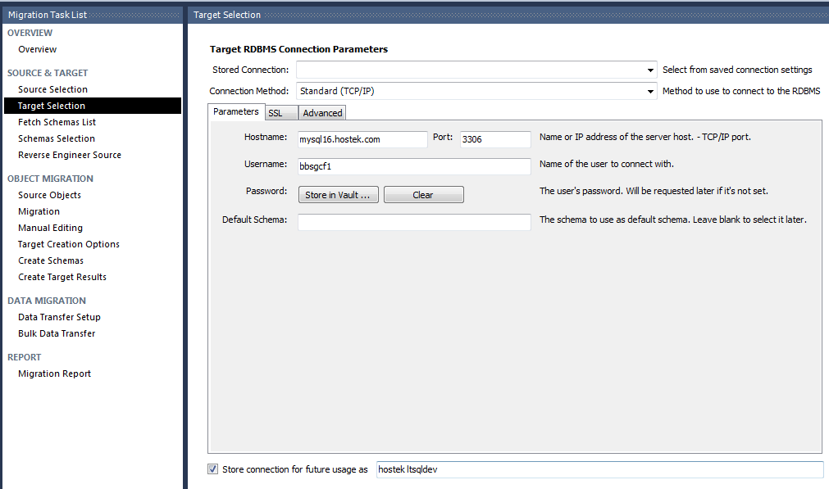ff